Ystradowen Community and Sports Association
Safeguarding Policy for the Ystradowen Village Hall
INTENT
The YCSA is fully committed to the safeguarding principles as set out in the Social Services and Well-being (Wales) Act 2014. The YCSA recognises that it has responsibilities for the safety and care of children under the Children Act 1989 and 2004. It also recognises its responsibilities to safeguarding Adults at Risk of Harm under the Care Act 2014. The YCSA Trustees and Committee will take reasonable steps to ensure that all YCSA members and Village Hall users are aware of the policy and their responsibilities to have due regard to the implementation of this policy.
This policy will apply to YCSA’s own premises and grounds as identified in the ground plan at Appendix 1.
PURPOSE
'Safeguarding means keeping people safe from abuse, neglect or harm and knowing what to do if you think a child or adult is at risk of abuse, neglect or harm.' (Welsh Government Code of Safeguarding Practice, 2022).
The purpose of this policy statement is to define how the YCSA operates to safeguard children and adults at risk of harm in order to;
- protect them from harm.
- provide Trustees, volunteers and users with the overarching principles that guide our approach to safeguarding.
CORE DUTIES OF THE YCSA
The Trustees and Management Committee have a duty of care and are committed to the protection and safety of everyone who visits Ystradowen Village Hall and its facilities, including children and adults at risk involved as visitors and participants in all of our activities. We also have a duty to safeguard and support our staff and volunteers.
The YCSA
- will keep the premises safe for all users including children and vulnerable adults;
- acknowledges a duty to safeguard all who use Ystradowen Village Hall;
- will communicate the existence of a Designated Safeguarding Person (DSP) together with a relevant email address and a contact telephone number on its website and on the Village Hall Notice Board
- will inform all hirers of their own responsibilities in this regard in the Hall Hire Agreement
- provides no supervisory function in respect of Hirers and User Groups whilst acknowledging a duty to safeguard all those who use the Hall and its facilities
- will not require DBS (Disclosure and Barring Service) checks for Trustees, volunteers or paid staff unless they have unsupervised access to children and vulnerable adults.

PEOPLE
This policy applies to everyone working or volunteering on behalf of the YCSA, including Trustees, paid staff, volunteers, sessional workers, agency staff and students.
The YCSA Trustees will be supplied at least annually with a copy of this Policy and in any event will approve any review of the policy made within the annual cycle;
The YCSA Management Committee will annually nominate a Designated Safeguarding Person (DSP) who must:
- undertake accredited training fit for this purpose;
- ensure knowledge of current legal requirements is maintained:
- be a conduit for communication should groups hiring the village hall require clarification on any procedures to be undertaken. The DSP is not required to inform the YCSA committee of reported incidents on the grounds of maintaining confidentiality, unless the incident is deemed ‘serious’ by the authorities.
IMPLEMENTATION
1. The YCSA
- will report incidents of concern to the The Vale of Glamorgan CBC Social Services Department and South Wales Police if there is ‘reasonable cause to suspect’ that an adult or child is at risk of, or suffering from, abuse harm or neglect.
- will ensure that individuals or group hirers are aware of their Safeguarding responsibilities when signing the Hall Hiring Contract by providing them with an electronic Easy Read Version of the Welsh Government Document Working Together To Keep People Safe - Rules For What To Do If You Run Activities For Children Or Adults in Wales. This can be found online at:
https://www.gov.wales/sites/default/files/publications/2022-04/working-together-to-keep-people-safe-easy-read_0.pdf
2. Within its general duty of care the YCSA will continue to work to keep the Village Hall safe for all users by:
- holding regular committee meetings to discuss premises maintenance needs and enhancements
- making minutes of committee meetings available on request and holding an Annual General Meeting of all members and user groups
- contracting to provide regular cleaning of the Hall and maintenance of its grounds
- investing in CCTV monitoring and electronic locking mechanisms
- encouraging all Hirers and Users Groups to announce the fire safety procedures at the start of all sessions, specifically unlock the fire doors for quick release (and secure them at the end of the session), point out the exits and indicate the collective gathering point.

RESPONSIBILITIES OF USER GROUPS & OTHER HIRERS
It is the hirer's responsibility to read the Ystradowen Village Hall Hire Agreement when a booking is made and follow the rules and regulations set out in the Hire Agreement to promote the health and safety of everyone attending the Hall and protect them from harm.
The Trustees and Management Committee take no action to vet the person(s) hiring the Hall.
COMMUNICATION
Hall Hire Agreements and other policy documents will be published on the YCSA website giving transparency of intent and expectation.
Notification of groups using the Village Hall and events led by the YCSA are communicated via email. This method of communication is optional and email addresses are provided to the YCSA with consent of the owner in line with the guidance given on the Data Protection Act (Wales) 2018.
Any information provided to the DSP will be forwarded to the relevant authorities as appropriate, to enable the best supportive environment for any vulnerable adult or child who has chosen to divulge information that is of concern. This will be enabled in a confidential, sensitive, non-judgmental and factual way and as a matter of urgency.

REPORTING CONCERNS

Any concerns or allegations of abuse against a child, vulnerable adult, or any user who attends the Hall, should be made to the Designated Safeguarding Person (DSP). This is:
Named DSP | e mail
Sara Russell | Ycsadsap1@gmail.com

The named person(s) has the responsibility for immediately assessing and if necessary reporting those concerns to the Vale of Glamorgan County Borough Council Safeguarding Team which can be contacted on 01446 725202 (Out of hours: 029 20 788570) or to South Wales Police on 101. If the named person(s) think that a child or vulnerable adult is in immediate danger of being harmed they will contact South Wales Police on 999.
Revision history
This policy and related guidance will be monitored by the Management Committee & Trustees on a regular basis for compliance and will be reviewed at least annually.
Date | Amendments | Signed (Trustees)
November 2022 | Policy Created | David Thursfield
March 2024 | Policy Fully Revised in light of 2022 Guidance
September 2026 | Change to Designated Safeguarding Person (DSP)

APPENDIX 1
SITE PLAN OF YCSA PROPERTY
In this policy Ystradowen Village Hall means the land marked below as:
- hatched green (WA 319956) shows the Hall buildings, tarmac car park, green space and natural pond
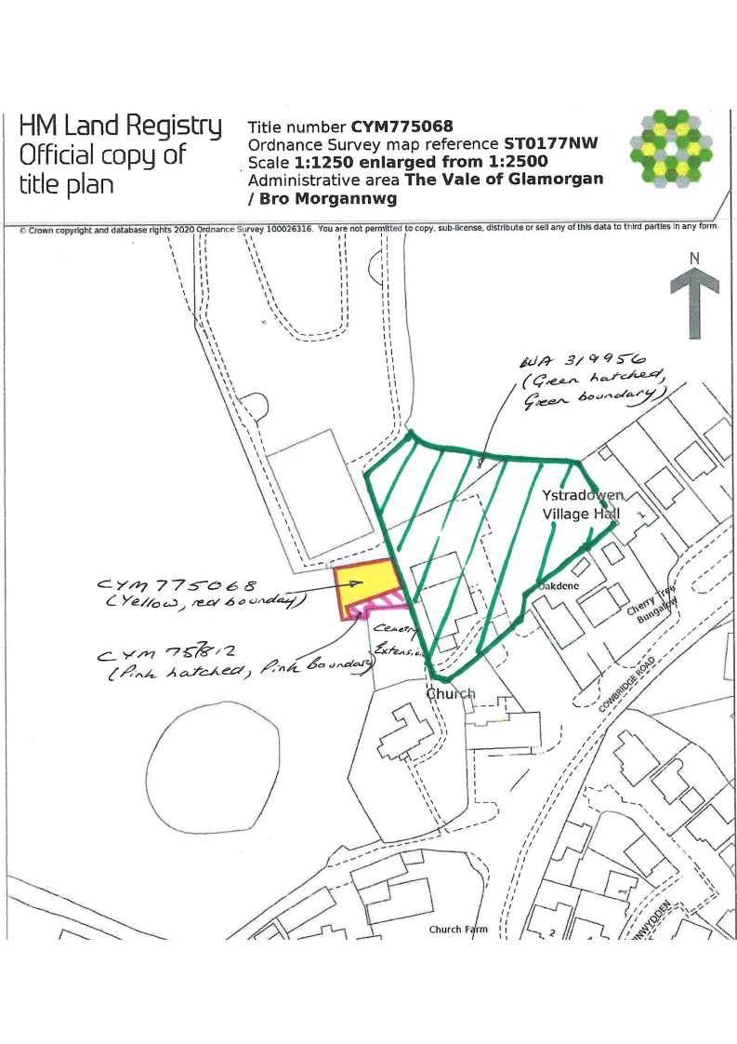
- hatched pink (CYM 757812) and block yellow CYM 775068) show additional 'green' parking spaces.

